Subject: Automotive Grade Processor

Roll No.CB.EN.U4CCE21009

# Project: Adaptive Cruise Control (ACC)

ABSTRACT:

ACC is an optional control system for vehicles that automatically adjusts the vehicle speed to maintain a safe distance from vehicles ahead. Control system consists of distance sensors like ultrasonic, radar. Following image provide an overview for ACC.

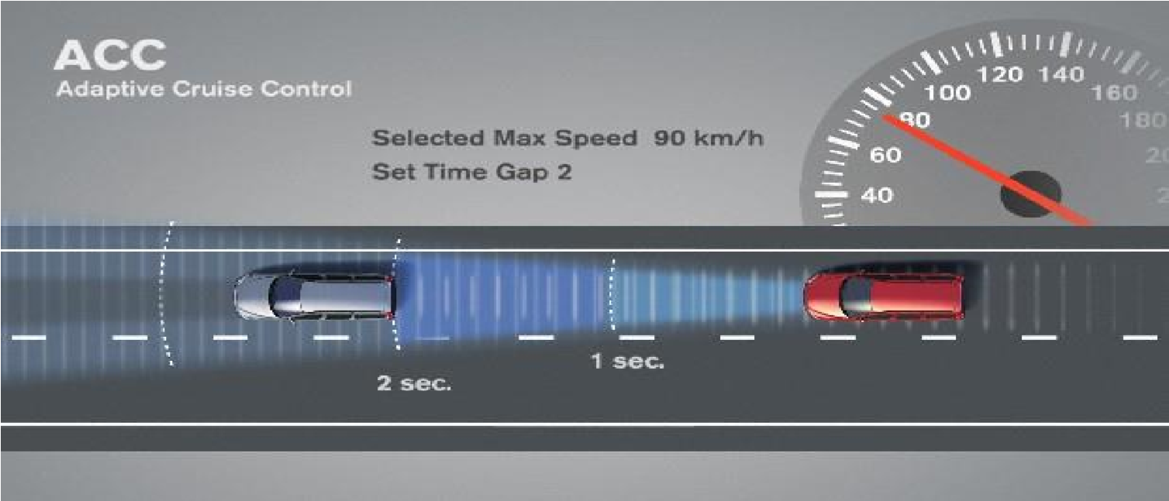

*Figure 1: Overview of Adaptive Cruise Control*

User control settings varies depending upon manufacturer, still basic functionalities are as follows:

1. Set max speed to be maintained.
2. Set minimum distance to be allowed with that speed.
3. Start ACC mode
4. Stop ACC mode
5. Store set parameters

Following are few kinds of setting arrangements is being provided:

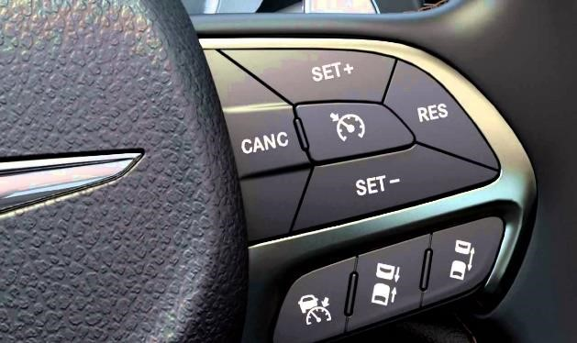 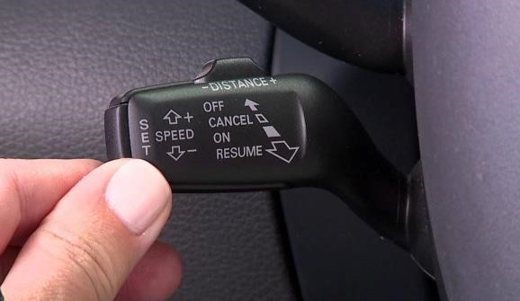

*Figure 2: Switch arrangement in vehicles*

BLOCK DIAGRAM: 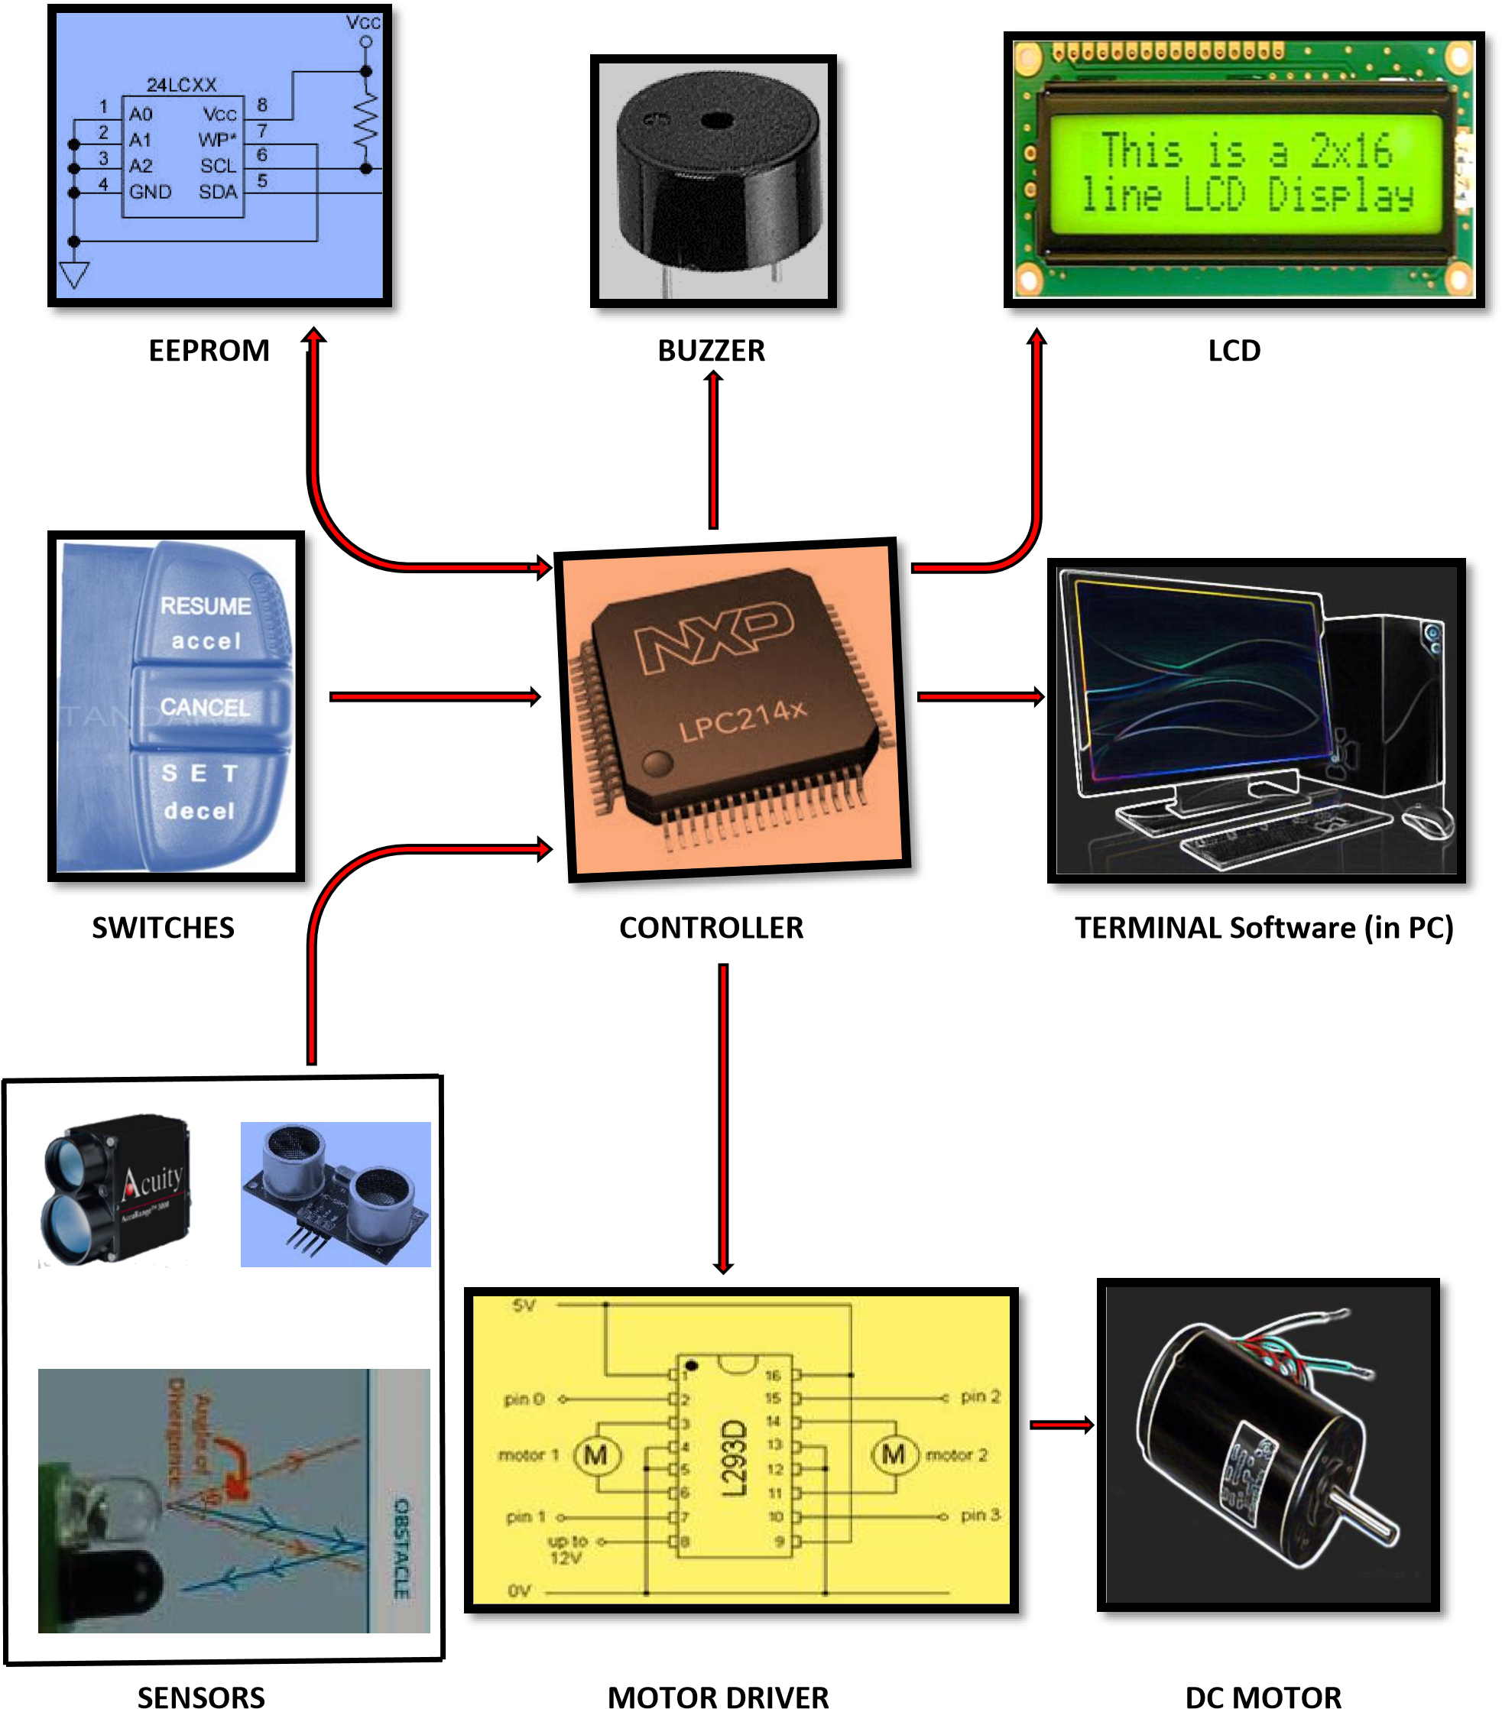

IMPLEMENTATION:

In this project ACC demonstration is done using Photo diode sensor to measure distance and included all above basic features using tactile switches.

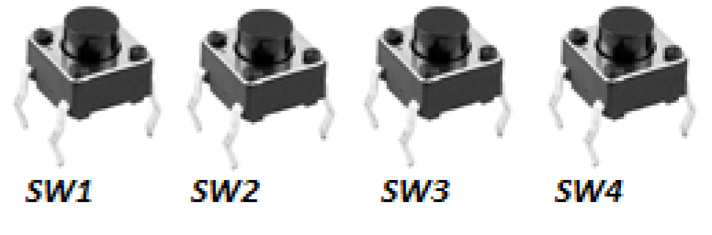

*Figure 3: Switches arrangement for demonstration*

## Operation:

* Press SW1 to go to speed and distance setting mode
* Using SW2 select parameter to select (Even press – Speed selected, Odd press – Distance selected)
* Using SW3 and SW4 for increment and decrement selected parameters respectively • Press SW1 again will ask for ACC starting confirmation.

[Note: Set data gets stored at this stage]

* Press SW1 again and ACC will start

[Note: During ACC mode speed will vary according distance between vehicles, this speed variation is just displayed on LCD and PWM is also generated accordingly] • Press SW1 to switch off ACC mode if turned ON.

## Constraints:

* Speed can be set is range between (40-80 Kmph) and distance (1-10m). [Note: these are not to the scale]
* If speed falls below 40Kmph ACC mode switched off with 3 beep indications. [Note: Each key stroke is provided with one beep stroke]

## Feature:

* Set values are stored in external EEPROM chip and are recalled during starting ACC mode.
* Per Speed change beep is provide to notify driver.

Following are components used:

1. LPC2148 development board
2. Photo diode sensor
3. UART to USB converter
4. Buzzer
5. LCD
6. EEPROM IC

|  |
| --- |
| Initialize LCD as 16x2 with 4 channel input |

PROGRAM FLOWCHART:

False

TRUE



Set default values



Continuously monitor Switches.

Monitor distance sensor if ACC is on with some

specific time period



Perform

operations as per

mentioned

above



Monitor Distance and keep changing

speed to maintain specified d

i

stance



If speed drops below

Kmph off ACC

40

mode with warning



Nod

e



Check whether set values

are in defined range

START



Initialise Port pins, ADC, PWM, I2C, UART0

|  |
| --- |
| Recall stored values from EEPROM |

SIMULATION:

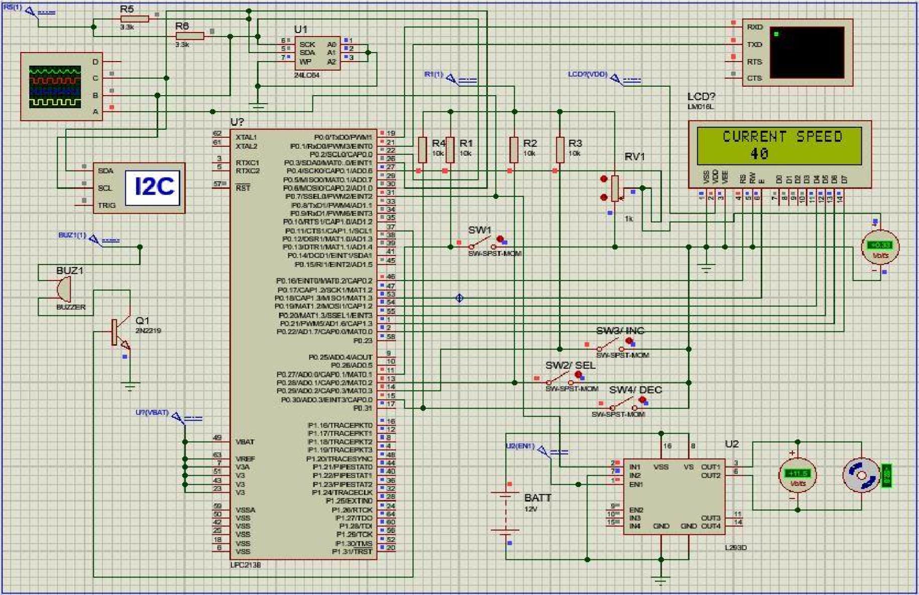

*Figure 4: Simulation circuit in proteus*

*Figure*

*5*

*:*

*Scope & terminal outputs*

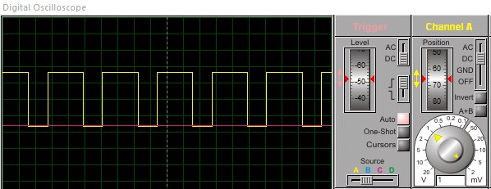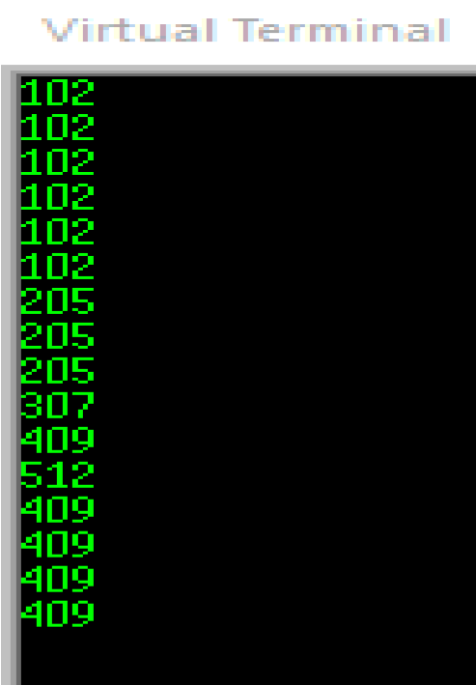

RESULTS:

*Figure*

*6*

*Photo*

*:*

*diode Sensor*

*Figure*

*7*

*LCD display as per mode change*

*:*

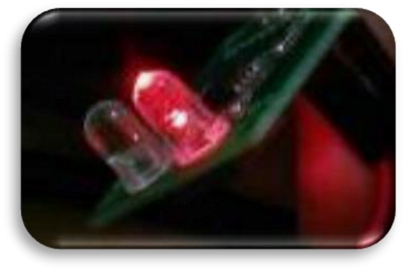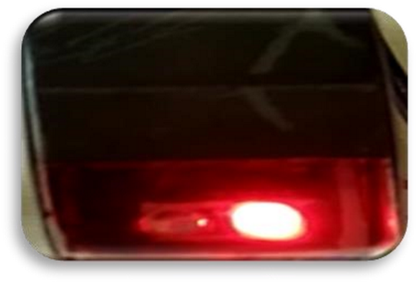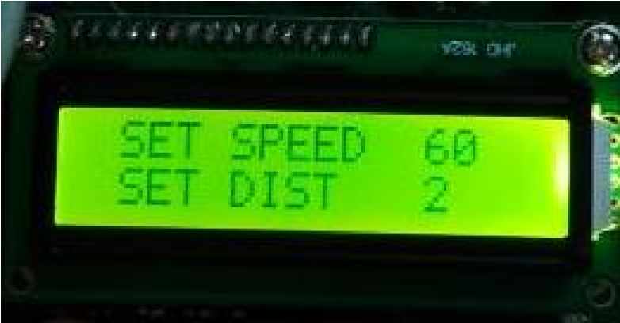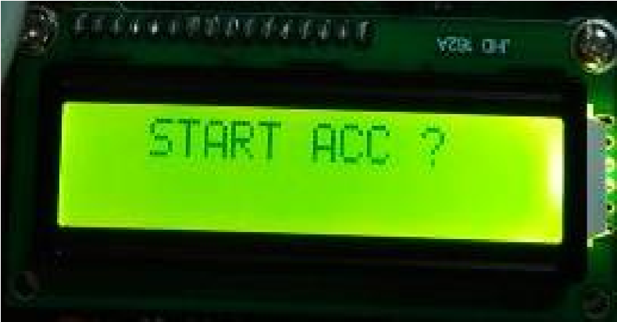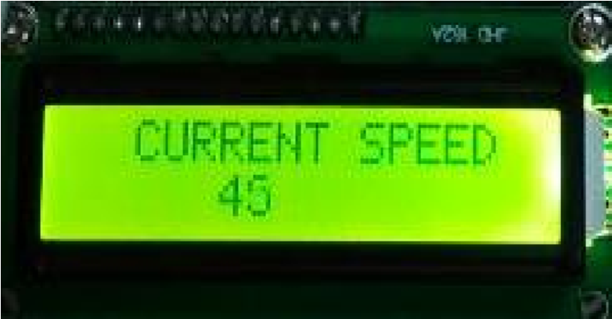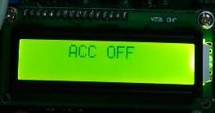

1

2

3

4

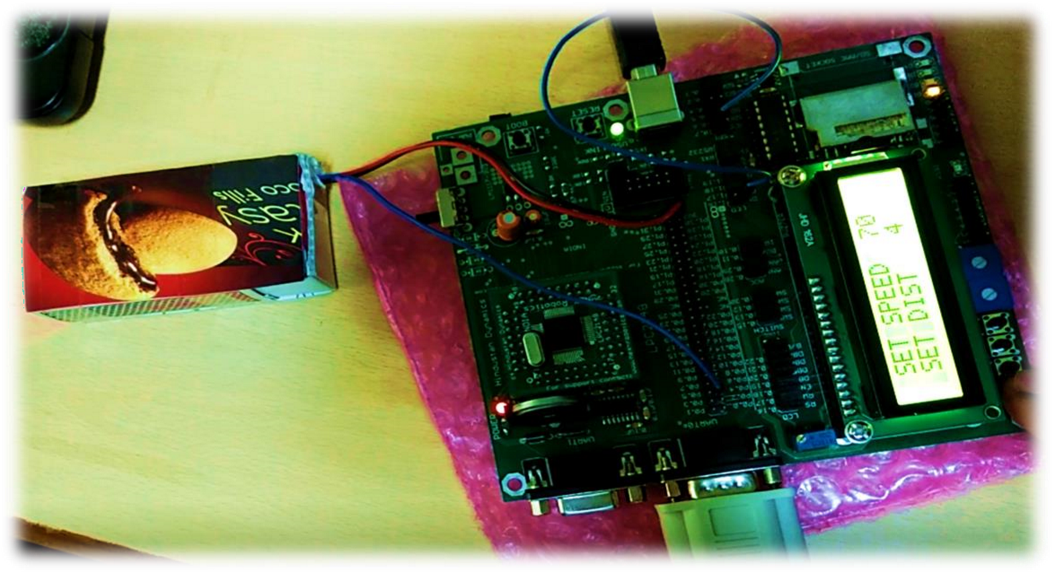

*Figure 8: Final demonstration setup*